UNIT-I

DC CIRCUITS

**INTRODUCTION:**

An Electric circuit is an interconnection of various elements in which there is at least one closed path in which current can flow. An Electric circuit is used as a component for any engineering system.

The performance of any electrical device or machine is always studied by drawing its electrical equivalent circuit. By simulating an electric circuit, any type of system can be studied for e.g., mechanical, hydraulic thermal, nuclear, traffic flow, weather prediction etc.

All control systems are studied by representing them in the form of electric circuits. The analysis, of any system can be learnt by mastering the techniques of circuit theory.

**Voltage:** Potential difference in electrical terminology is known as voltage, and is denoted either by V or 𝑣. It is expressed in terms of energy (w) per unit charge(Q).

V = W or V = dw

Q dq

𝑑 is the small change in energy

𝑑 is the small change in charge.

Where energy (W) is expressed in Joules (J), charge (Q) in coulombs (C), and voltage

(V) in volts(V). One volt is the potential difference between two points when one joule of energy is used to pass one coulomb of charge from one point to the other.

**Current:** Current is defined as the rate of flow of electrons in a conductive or semi conductive material. It is measured by the number of electrons that flow past a point in unit time.

Q

I = t

Where I is the current, Q is the charge of electrons, and t is the time

dq

i = dt

𝑑𝑞 is the small change in charge

𝑑 is the small change in time.

In practice, the unit ampere is used to measure current, denoted by A.

**Power and Energy:** Energy is nothing but stored work. Energy may exist in many forms such as mechanical, chemical, electrical and so on.

Power is the rate of change of energy, and is denoted by either P or p. if certain amount of energy over a certain length of time, then

Power (P) = energy / time= W/t

dw

P = dt

Were 𝑑𝑤 is the charge in energy and 𝑑𝑡 is the charge in time.

dw dw dq

P = dt =

dq X dt

P= V x I =VI= I2R

P= V x I =VI= I2R

V= w

q

W=vq

P= d(vq) = vdq

dt dt

P=VI Watts

W= ∫ pdt Joules

1.1.1. Elements of an Electric circuit:

An Electric circuit consists of two types of elements

1. Active elements or sources
2. Passive elements or sinks

Active elements are the elements of a circuit which possess energy of their own and can impart it to other element of the circuit.

Active elements are of two types

1. Voltage source b) Current source

A Voltage source has a specified voltage across its terminals, independent of current flowing through it.

A current source has a specified current through it independent of the voltage appearing across it.

* 1. Independent & Dependent sources

If the voltage of the voltage source is completely independent source of current and the current of the current source is completely independent of the voltage, then the sources are called as independent sources.

The special kind of sources in which the source voltage or current depends on some other quantity in the circuit which may be either a voltage or a current anywhere in the circuit are called Dependent sources or Controlled sources.

There are four possible dependent sources.

1. Voltage dependent Voltage source
2. Current dependent Current source
3. Voltage dependent Current source
4. Current dependent Current source

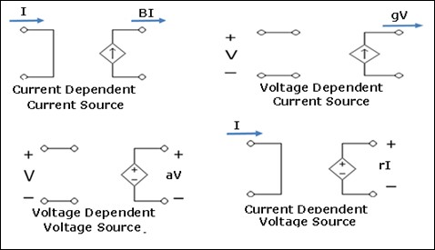

The constants of proportionalities are written as B, g, a, r in which B & a has no units, r has units ohm & g has units mhos.

Independent sources actually exist as physical entities such as battery, a dc generator & an alternator. But dependent sources are used to represent electrical properties of electronic devices such as OP-AMPS & Transistors.

* 1. Ideal & Practical sources

An ideal voltage source is one which delivers energy to the load at a constant terminal voltage, irrespective of the current drawn by the load.

An ideal current source is one, which delivers energy with a constant current to the load, irrespective of the terminal voltage across the load.

A Practical source always possesses a very small value of internal resistance r. The internal resistance of a voltage source is always connected in series with it & for a current source, it is always connected in parallel with it.

As the value of the internal resistance of a practical voltage source is very small, its terminal voltage is assumed to be almost constant within a certain limit of current flowing through the load.

A practical current source is also assumed to deliver a constant current, irrespective of the terminal voltage across the load connected to it.

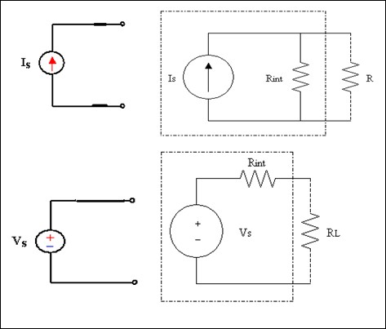

Ideal voltage source connected in series

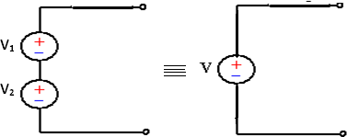

The equivalent single ideal voltage some is given by V= V1 + V2

Any number of ideal voltage sources connected in series can be represented by a single ideal voltage some taking in to account the polarities connected together in to consideration.

Practical voltage source connected in series:

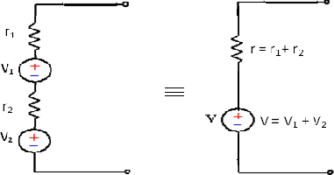

**Ideal voltage source connected in parallel:**

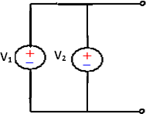

When two ideal voltage sources of emf’s V1 & V2 are connected in parallel, what voltage appears across its terminals is ambiguous. Hence such connections should not be made.

However if V1 = V2= V, then the equivalent voltage some is represented by V.

In that case also, such a connection is unnecessary as only one voltage source serves the purpose.

Practical voltage sources connected in parallel:

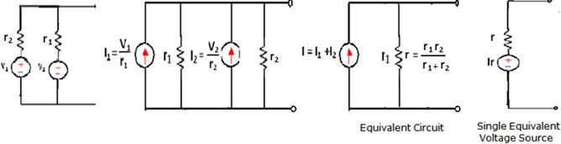

**Ideal current sources connected in series:**

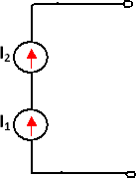

When ideal current sources are connected in series, what current flows through the line is ambiguous. Hence such a connection is not permissible.

However, it I1 = I2 = I, then the current in the line is I.

But, such a connection is not necessary as only one current source serves the purpose.

Practical current sources connected in series:

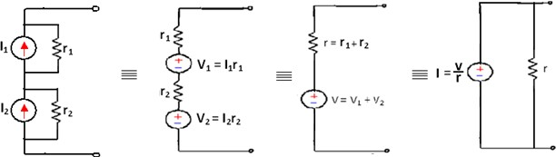

**Ideal current sources connected in parallel:**

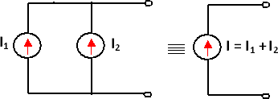

Two ideal current sources in parallel can be replaced by a single equivalent ideal current source.

Practical current sources connected in parallel:

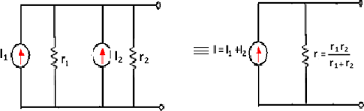

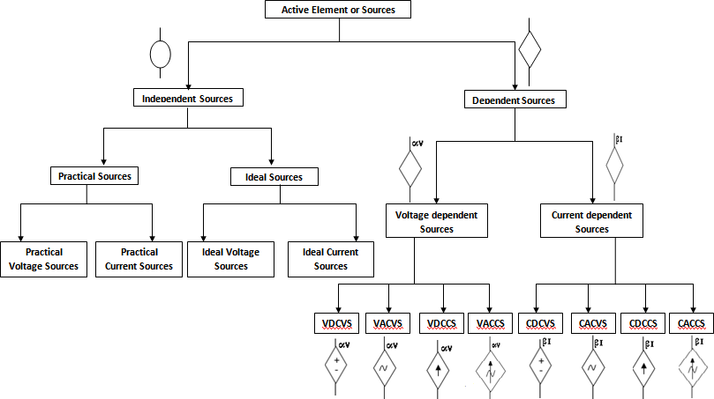

* 1. **Source transformation**

A current source or a voltage source drives current through its load resistance and the magnitude of the current depends on the value of the load resistance.

Consider a practical voltage source and a practical current source connected to the same load resistance RL as shown in the figure.

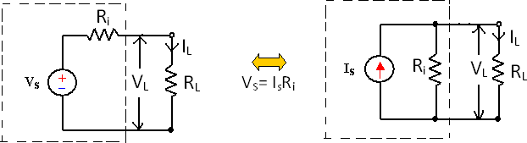

Fig. a Fig. b

R1’s in figure represents the internal resistance of the voltage source VS and current source IS.

Two sources are said to be identical, when they produce identical terminal voltage VL and load current IL. The circuits in figure represent a practical voltage source & a practical current source respectively, with load connected to both the sources. The terminal voltage VL and load current IL across their terminals are same. Hence the practical voltage source & practical current source shown in the dotted box of figure are equal.

The two equivalent sources should also provide the same open circuit voltage & short circuit current.

From fig (a) From fig (b)

𝑉𝑠 𝑟

IL =

𝑅+𝑅𝐿

∴ 𝑉𝑠

𝑅+𝑅𝐿

𝑟

= I

𝑅+𝑅𝐿

# 𝑉𝑠

IL = I

𝑅+𝑅𝐿

VS = IR or I =

# 𝑅

Hence a voltage source Vs in series with its internal resistance R can be converted into a current source I = 𝑉𝑠, with its internal resistance R connected in parallel

n

with it. Similarly a current source I in parallel with its internal resistance R can be converted into a voltage source V = IR in series with its internal resistance R.

* 1. Passive Elements:

The passive elements of an electric circuit do not possess energy of their own. They receive energy from the sources. The passive elements are the resistance, the inductance and the capacitance. When electrical energy is supplied to a circuit element, it will respond in one and more of the following ways.

If the energy is consumed, then the circuit element is a pure resistor. If the energy is stored in a magnetic field, the element is a pure inductor. And if the energy is stored in an electric field, the element is a pure capacitor.

* + 1. Linear and Non-Linear Elements.

Linear elements show the linear characteristics of voltage & current. That is its voltage-current characteristics are at all-times a straight-line through the origin.

For example, the current passing through a resistor is proportional to the voltage applied through its and the relation is expressed as V ∝ I or V = IR. A linear element or network is one which satisfies the principle of superposition, i.e., the principle of homogeneity and additive.

Resistors, inductors and capacitors are the examples of the linear elements and their properties do not change with a change in the applied voltage and the circuit current.

Non linear element’s V-I characteristics do not follow the linear pattern i.e. the current passing through it does not change linearly with the linear change in the voltage across it. Examples are the semiconductor devices such as diode, transistor.

* + 1. Bilateral and Unilateral Elements:

An element is said to be bilateral, when the same relation exists between voltage and current for the current flowing in both directions.

Ex: Voltage source, Current source, resistance, inductance & capacitance. The circuits containing them are called bilateral circuits.

An element is said to be unilateral, when the same relation does not exist between voltage and current when current flowing in both directions. The circuits containing them are called unilateral circuits.

Ex: Vacuum diodes, Silicon Diodes, Selenium Rectifiers etc.

1.5.3. Lumped and Distributed Elements

Lumped elements are those elements which are very small in size & in which simultaneous actions takes place. Typical lumped elements are capacitors, resistors, inductors.

Distributed elements are those which are not electrically separable for analytical purposes.

For example a transmission line has distributed parameters along its length and may extend for hundreds of miles.

The circuits containing them are called unilateral circuits.

* 1. Voltage Current Relationship for passive elements

**Resistance**

Resistance is that property of a circuit element which opposes the flow of electric current and in doing so converts electrical energy into heat energy.

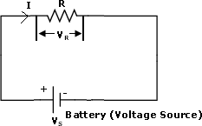

It is the proportionality factor in ohm’s law relating voltage and current.

Ohm’s law states that the voltage drop across a conductor of given length and area of cross section is directly proportional to the current flowing through it.

v œ I VR= RI

𝑣

R= ohms= GV

𝐼

Where the reciprocal of resistance is called conductance G. The unit of resistance is ohm and the unit of conductance is mho or Siemens.

When current flows through any resistive material, heat is generated by the collision of electrons with other atomic particles. The power absorbed by the resistor is converted to heat and is given by the expression

P= VI=I2R watts

= V ( ) = 𝑉2 watts

𝑅 𝑅

Where I is the resistor in amps, and V is the voltage across the resistor in volts. Energy lost in a resistance in time t is given by

W= t Pdt = Pt = i2Rt = V2 t Joules

∫

0 R

Resistance in series:



**Series:** V=V1+V2+V3

V= IR1+IR2+IR3 = I(R1+R2+R3) (1)

V = IReq (2)

From (1) & (2)

IReq = I(R1+R2+R3) Req = R1+R2+R3





Resistance in parallel:

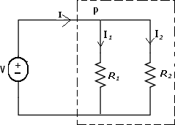

Apply KCL at P

I =I1+I2

I **=** V + V =v [ 1 + 1 ] …..(1)

R1 R2 R1 R2

v

From (1) =(2)

I =

Req

…..(2)

V

Req

1

Req

1

= v [

R1

= 1

R1

+ 1 ]

R2

+ 1

R2

Req

= R1R2 R1+R2

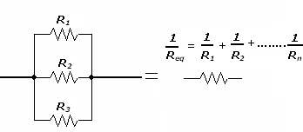

Inductance :

Inductance is the property of a material by virtue of which it opposes any change of magnitude and direction of electric current passing through conductor. A wire of certain length, when twisted into a coil becomes a basic conductor. A change in the magnitude of the current changes the electromagnetic field.

Increase in current expands the field & decrease in current reduces it.A change in current produces change in the electromagnetic field. This induces a voltage across the coil according to Faradays laws of Electromagnetic Induction.

Induced Voltage V = L 𝑑𝑖

𝑑𝑡

V = Voltage across inductor in volts

I = Current through inductor in amps

Integrating both sides,

t

di =

##### 1

v dt

##### 𝐿

t

1

∫ di = L ∫ vdt

0 0

Power absorbed by the inductor P = Vi = Li Energy stored by the inductor

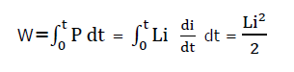

##### di

Watt

##### dt

Li2

W =

##### 2

Joules

Conclusions:

di

1. V = L

##### dt

The induced voltage across an inductor is zero if the current through it is constant. That means an inductor acts as short circuit to dc.

1. For minute change in current within zero time (dt = 0) gives an infinite voltage across the inductor which is physically not at all feasible.

In an inductor, the current cannot change abruptly. An inductor behaves as open circuit just after switching across dc voltage.

1. The inductor can store finite amount of energy, even if the voltage across the inductor is zero.
2. A pure inductor never dissipates energy, it only stores it. Hence it is also called as a non–dissipative passive element. However, physical inductor dissipate power due to internal resistance.

1.) The current in a 2H inductor raises at a rate of 2A/s .Find the voltage across the inductor & the energy stored in the magnetic field at after 2sec.

##### di

V = L

##### dt

= 2X2 = 4V

W = 1 Li2 = 1 X 2 X (4)2 = 16 J

2 2

Inductance in series:

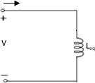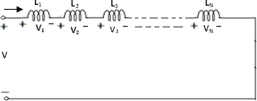

V(t) = V1 (t) + V2 (t)

= L1

𝑑𝑖

𝑑𝑡

di

+ L2

dt

= (L1 + L2 )

∴ **Leq = L1 + L2**

di di

= Leq

dt dt

In `n` inductances are in series, then the equivalent inductance

**Leq = L1 + L2 + +Ln**

Inductances in parallel:

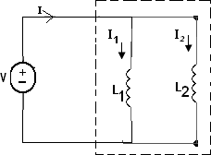

I (t) = I1(t) + I2(t)

1

= ∫ vdt +

L1

1 1

∫ vdt = (

L2 L1

1

1

## + ) ∫ vdt

L2

#### =

Leq

1

## ∫ vdt

1 1

#### ∴

Leq

## = ( + )

L1 L2

In `n` Inductances are connected in parallel, then

Capacitance:

1

Leq

= 1 + 1

L1 L2

+ … … … . + 1

Ln

Henrys

* A capacitor consists of two metallic surfaces or conducting surfaces separated by a dielectric medium.
* It is a circuit element which is capable of storing electrical energy in its electric field.
* Capacitance is its capacity to store electrical energy.
* Capacitance is the proportionality constant relating the charge on the conducting plates to the potential.

Charge on the capacitor q α V

q = CV

Where `C` is the capacitance in farads, if q is charge in coulombs and V is the potential difference across the capacitor in volts.

The current flowing in the circuit is rate of flow of charge

dq dv

i = = C

dt dt

## ∴ i = c

dv

amps

dt

The capacitance of a capacitor depends on the dielectric medium & the physical dimensions. For a parallel plate capacitor, the capacitance

*€*𝐴

C =

##### 𝐷

= €0 €r 𝐴

##### 𝐷

A is the surface area of plates

D is the separation between plates

€ is the absolute permeability of medium

€0 is the absolute permeability of free space

€r is the relative permeability of medium

dq dv

I = = C

dt dt

##### dv = i dt c

V =

1

∫ idt Volts

c

##### dv

The power absorbed by the capacitor P = vi = vc

##### dt

###### Watt

t

Energy stored in the capacitor W = ∫0 Pdt

t dv

= ∫0 vc dt dt

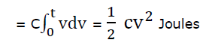

This energy is stored in the electric field set up by the voltage across capacitor.

Capacitance in series:

Let C1 , C2 be the two capacitances connected in series and let V1,V2 be the p.ds across the two capacitors. Let V be the applied voltage across the combination and C, the combined or equivalent capacitance. For a series circuit, charge on all capacitors is same but P.d across each is different.

V=V1+V2

And so from the circuit diagram it is shown that,

V = 1 ∫ Idt + 1

C1 C2

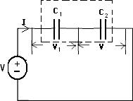1 1

∫ Idt

V = (

C1

1

+ ) ∫ Idt (1)

C2

V =

Ceq

∫ Idt (2)

1

Ceq

= 1 + 1

C1 C2

Ceq

= C1 C2 C1+ C2

C n series

Capacitance in parallel:

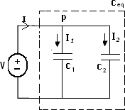

**Conclusions:**

The current in a capacitor is zero, if the voltage across it is constant, that means the capacitor acts as an open circuit to dc

1. A small change in voltage across a capacitance within zero time gives an infinite current through the capacitor, which is physically impossible.

∴ In a fixed capacitor, the voltage cannot change abruptly

∴ A capacitor behaves as short circuit just after switching across dc voltage.

1. The capacitor can store a finite amount of energy, even if the current through it is zero.
2. A pure capacitor never dissipates energy but only stores it hence it is called non- dissipative element.

V-I Relation of circuit elements

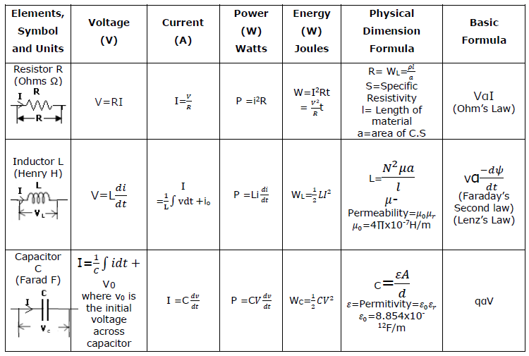

**Problems:**

1. **The Current function shown below is a repeating square wave. With this current existing in a pure resistor of 10Ω, plot voltage V(t) & power P(t)**

V(t) = R i(t) P = Vi

= 10X5 = 50 = 50X5 = 250w

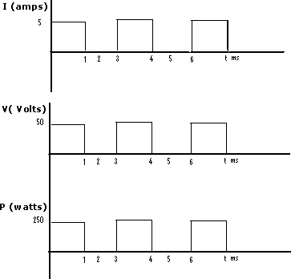

1. The current function for a pure resistor of 5 Ω is a repeating saw tooth as shown below. Find v(t), P(t).

V(t) = R i(t) = 5 X 10 = 50 V

0‹t‹2ms

𝑖 = 10

= 5𝑋103 𝑖 = 5𝑋103𝑡

𝑡 2𝑋10−3

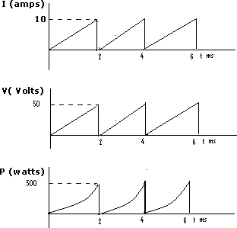V=5X5X103t =25X103 P=125X106t2

P (watts) 10V (Volts)

1. **A pure inductance L = 0.02H has an applied voltage V(t) = 150 sin 1000t volts. Determine the current i(t), & draw their wave forms**

V(t) = 150 sin 1000t L = 0.02H

I(t) = 1 ∫ 𝑉𝑑𝑡 = 1 ∫ 150 sin 1000tdt

𝐿 0.02

150 (–cos 1000𝑡)

0.02 1000

∴i(t)= -7.5 cos 1000t Amps

P=V(t) i(t) =(-150) (7.5) 1 sin 2000𝑡 = -562.5 sin 2000t

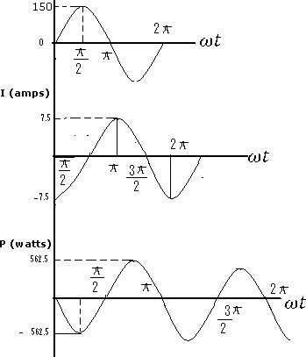2

Kirchhoff`s Laws

Kirchhoff’s laws are more comprehensive than Ohm's law and are used for solving electrical networks which may not be readily solved by the latter.

Kirchhoff`s laws, two in number, are particularly useful in determining the equivalent resistance of a complicated network of conductors and for calculating the currents flowing in the various conductors.

1. Kirchhoff`s Point Law or Current Law (KCL):

In any electrical network, the algebraic sum of the currents meeting at a point (or junction) is Zero.

That is the total current ***entering*** a junction is equal to the total current ***leaving***

that junction.

Consider the case of a network shown in Fig

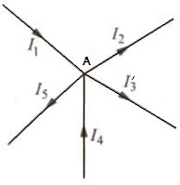

I1+(-I2)+(I3)+(+I4)+(-I5) = 0

I1+I4-I2-I3-I5 = 0 Or I1+I4 = I2+I3+I5

Or Incoming currents =Outgoing currents

1. Kirchhoff's Mesh Law or Voltage Law (KVL):

In any electrical network, the algebraic sum of the products of currents and resistances in each of the conductors in any closed path (or mesh) in a network plus the algebraic sum of the e.m.f.’s. in that path is zero***.***

That is, ∑*IR* + ∑*e.m.f* = 0 round a mesh

It should be noted that algebraic sum is the sum which takes into account the polarities of the voltage drops.

That is, if we start from a particular junction and go round the mesh till we come back to the starting point, then we must be at the same potential with which we started.

Hence, it means that all the sources of emf met on the way must necessarily be equal to the voltage drops in the resistances, every voltage being given its proper sign, plus or minus.

**Determination of Voltage Sign**

In applying Kirchhoff's laws to specific problems, particular attention should be paid to the algebraic signs of voltage drops and e.m.fs.

1. Sign of Battery E.M.F.

A *rise* in voltage should be given a + ve sign and *a fall* in voltage a -ve sign. That is, if we go from the -ve terminal of a battery to its +ve terminal there is a *rise* in potential, hence this voltage should be given a + ve sign. And on the other hand, we go from +ve terminal to -ve terminal, then there is *a fall* in potential, hence this voltage should be preceded by a -ve sign.

The sign of the battery e.m.f is independent of the direction of the current through that branch.

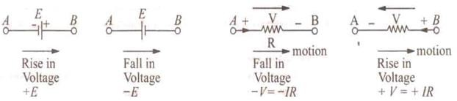

1. **Sign of *IR* Drop**

Now, take the case of a resistor (Fig. 2.4). If we go through a resistor in the *same* direction as the current, then there is a fall in potential because current flows from a higher to a lower potential.

Hence, this voltage fall should be taken -ve. However, if we go in a direction opposite to that of thecurrent, then there is a *rise* in voltage. Hence, this voltage rise should be given a positive sign.

Consider the closed path *ABCDA* in Fig .

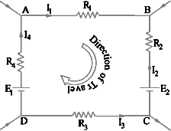

As we travel around the mesh in the clockwise direction, different voltage drops will have the following signs :

*I1R1* is - ve (fall in potential) *I2R2* is - ve (fall in potential) *I3R3* is + ve (rise in potential) *I4R4* is - ve (fall in potential) *E2* is - ve (fall in potential) *E1* is + ve (rise in potential)

Using Kirchhoff's voltage law, we get

-I1R1 – I2R2 – I3R3 – I4 R4 – E2 + E1 = 0 Or I1R1 + I2R2 – I3R3 + I4R4 = E1 –E2

Assumed Direction of Current:

In applying Kirchhoff's laws to electrical networks, the direction of current flow may be assumed either clockwise or anticlockwise. If the assumed direction of current is not the actual direction, then on solving the question, the current will be found to have a minus sign.

If the answer is positive, then assumed direction is the same as actual direction. However, the important point is that once a particular direction has been assumed, the same should be used throughout the solution of the question.

Kirchhoff's laws are applicable both to d.c. and a.c. voltages and currents. However, in the case of alternating currents and voltages, any e.m.f. of self-inductance or that existing across a capacitor should be also taken into account.

NETWORK REDUCTION TECHNIQUES:

**Resistance in series:**

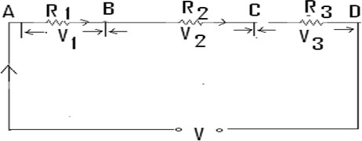If three conductors having resistances R1, R2 and R3 are joined end on end as shown in fig below, then they are said to be connected in series. It can be proved that the equivalent resistance between points A & D is equal to the sum of the three individual resistances.

For a series circuit, the current is same through all the three conductors but voltage drop across each is different due to its different values of resistances and is given by ohm`s Law and the sum of the three voltage drops is equal to the voltage supplied across the three conductors.

∴ V= V1+V2+V3 = IR1+IR2+IR3

But V= IR

where R is the equivalent resistance of the series combination.

IR = IR1+IR2+IR3 or *R* = R1 + *R2*+ R3

The main characteristics of a series circuit are

* 1. Same current flows through all parts of the circuit.
  2. Different resistors have their individual voltage drops.
  3. Voltage drops are additive.
  4. Applied voltage equals the sum of different voltage drops.
  5. Resistances are additive.
  6. Powers are additive

Voltage Divider Rule

In a series circuit, same current flows through each of the given resistors and the voltage drop varies directly with its resistance.

Q.) Consider a circuit in which, a 24- V battery is connected across a series combination of three resistors of 2Ω, 4Ω and 6Ω. Determine the voltage drops across each resistor?

Ans) Total resistance *R* = *R* 1 + *R2* + R3= 12 Ω

According to Voltage Divider Rule, voltages divide in the ratio of their resistances and hence the various voltage drops are

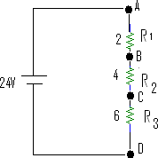𝑅1 2

𝑉1 = 𝑉 𝑅 = 24 𝑋 12 = 4𝑉

𝑉 = 𝑉 𝑅2 = 24 𝑋 4 = 8𝑉

2 𝑅 12

###### 𝑅3 6

𝑉3 = 𝑉 𝑅 = 24 𝑋 12 = 12𝑉

Resistances in Parallel:

Three resistances, as joined in Fig are said to be connected in parallel. In this case

1. Potential difference across all resistances is the same
   1. Current in each resistor is different and is given by Ohm's Law And
   2. The total current is the sum of the three separate currents.

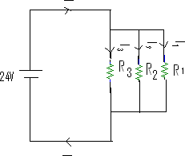

I = I*1+I2 +I3 =*

𝑉

𝑅1

+ 𝑉

𝑅2

+ 𝑉

𝑅3

I = V where *V* is the applied voltage.

R

R = equivalent resistance of the parallel combination.

𝑉 = 𝑉

+ 𝑉

+ 𝑉

𝑅 𝑅1

𝑅2

𝑅3

1 = 1 + 1 + 1

𝑅 𝑅1 𝑅2 𝑅3

G = GI + G2+ G3

The main characteristics of a parallel circuit are:

1. Same voltage acts across all parts of the circuit
2. Different resistors have their individual current.
3. Branch currents are additive.
4. Conductance’s are additive.
5. Powers are additive

Division of Current in Parallel Circuits

Two resistances are joined in parallel across a voltage *V. The current in each*

branch, given by Ohm’s law, is

##### 𝑉

I1=

𝑉

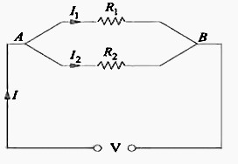and I2=

𝐼1

𝐼2

𝑅1

= 𝑅2

𝑅1

1

𝑅2

1

As

𝑅1

= 𝐺1 𝑎𝑛𝑑

𝑅2

= 𝐺2

𝐼1

𝐼2

= 𝐺1

𝐺2

Hence, the division of current in the branches of a parallel circuit is directly

Proportional to the conductance of the branches or inversely proportional to their resistances.

The branch currents are also expressed in terms of the total circuit current

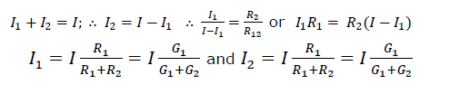

This Current Divider Rule has direct application in solving electric circuits by Norton's theorem

Take the case of three resistors in parallel connected across a voltage V Total current is *I=I1+I2+I3*

Let the equivalent resistance be *R.* Then

*V* = IR

Also *V* = I1*R, lR* = I1*R*

𝐼

Or

𝐼1

= 𝑅1

𝑅

𝑜𝑟 𝐼1

= 𝐼𝑅

𝑅1

1 = 1

𝑅 𝑅1

+ 1

𝑅2

+ 1

𝑅3

R = 𝑅1𝑅2𝑅3

𝑅1𝑅3+𝑅2𝑅3+𝑅1𝑅2

From …. (i) above, I1

= I[ 𝑅2𝑅3

𝑅1𝑅3+𝑅2𝑅3+𝑅1𝑅2

] = 𝐼. 𝐺1

𝐺1+𝐺2+𝐺3

I = I[ 𝑅1𝑅3 ] = 𝐼. 𝐺2

2

𝑅1𝑅3+𝑅2𝑅3+𝑅1𝑅2

I = I[ 𝑅1𝑅2

3

𝑅1𝑅3+𝑅2𝑅3+𝑅1𝑅2

𝐺1+𝐺2+𝐺3

] = 𝐼. 𝐺3

𝐺1+𝐺2+𝐺3

**Introduction**

**Basic Terms used in a Circuit**

1. ***Circuit:*** A circuit is a closed conducting path through which an electric current either flows or is intended flow.
2. ***Network:*** A combination of various electric elements, connected in any manner.
3. ***Linear Circuit:*** A linear circuit is one whose parameters are constant *i.e.* they do not change with voltage or current.
4. ***Non-linear Circuit:*** It is that circuit whose parameters change with voltage or current.
5. ***Bilateral Circuit:*** A bilateral circuit is one whose properties or characteristics are the same in either direction. The usual transmission line is bilateral, because it can be made to perform its function equally well in either direction.
6. ***Unilateral Circuit:*** It is that circuit whose properties or characteristics change with the direction of its operation. A diode rectifier is a unilateral circuit, because it cannot perform rectification in both directions.
7. ***Parameters:*** The various elements of an electric circuit are called its parameters like resistance, inductance and capacitance. These parameters may be *lumped or distributed*.
8. ***Passive Network*** is one which contains no source of e.m.f. in it.
9. ***Active Network*** is one which contains one or more than one source of e.m.f.
10. ***Node:*** I t is a junction in a circuit where two or more circuit elements are connected together.
11. ***Branch:*** It is that part of a network which lies between two junctions.
12. ***Loop:*** It is a close path in a circuit in which no element or node is encountered more than once.
13. ***Mesh:*** It is a loop that contains no other loop within it.

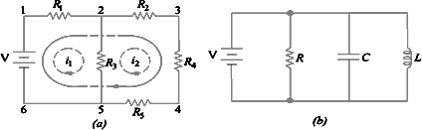

Consider the circuit of Fig. (*a*).

It has seven branches, six nodes, three loops and two meshes and the circuit of Fig (*b*) has four branches, two nodes, six loops and three meshes.

2. MESH ANALYSIS AND NODAL ANALYSIS

The simple series & parallel circuits can be solved by using ohm`s law & Kirchhoff’s law.

If the circuits are complex with several sources & a large number of elements, they may be simplified using star-delta transformation. There are also other effective solving methods of complex electric circuits.

Mesh current or loop current analysis & node voltage analysis are the two very effective methods of solving complex electric circuits. We have various network theorems which are also effective alternate methods to solve complex electrical circuits

1. Mesh current or loop current analysis
2. Node voltage analysis
   1. Mesh Analysis:

It is combination of KVL (Kirchhoff’s Voltage Law) and Ohms law

This method which is particularly applied to complete networks employs a system of loop or mesh currents instead of branch currents as in Kirchhoff`s law. Here, the currents in different meshes are assigned another path so that they do not split at a junction in to branch currents. This method eliminates a great deal of tedious work involved in the branch-current method and is best suited when energy sources are voltage sources rather than current sources. Basically, this method consists of writing loop voltage equations by Kirchhoff’s voltage law in terms of unknown loop currents.

If `b` is the number of branches & j is the number of junctions in a given network, then the total number of independent equations to be solved reduces from `b` by Kirchhoff`s law to b-(j-1) for loop current method.

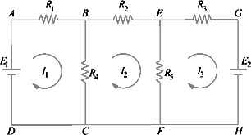

Fig. shows two batteries E1 and E2 connected in a network consisting of five resistors. Let the loop currents for the three meshes be I1, I2 and I3. It is obvious that current through R4 (when considered as a part of the first loop) is (I1 −I2) and that through R5 is

(I2 −I3). However, when R4 is considered part of the second loop, current through it is (I2 − I1). Similarly, when R5 is considered part of the third loop, current through it is (I3−I2).

Applying Kirchhoff’s voltage law to the three loops, we get,

E1 −I1R1 −R4 (I1 −I2) = 0 or I1 (R1 + R4) −I2 R4 −E1 = 0 ……Loop (1)

Similarly, −I2R2 −R5 (I2 −I3) −R4 (I2 −I1) = 0 or I2 R4 −I2 (R2 + R4 + R5) + I3R5 = 0 ……Loop(2)

Also −I3R3 −E2 −R5 (I3 −I2) = 0 or I2R5 −I3 (R3 + R5) −E2 = 0 ….Loop (3)

The above three equations can be solved not only to find loop currents but branch currents as well.

*Example 1*: Find the power dissipated in 2Ω resistor in the circuit given below.

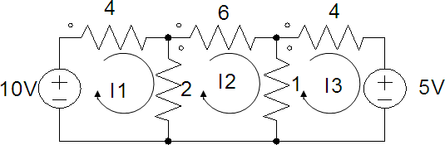

*Solution:*

For mesh (1)

-10+4 I1+2(I1-I2) =0

6I1-2I2=10 (1)

For mesh (2)

6 I2+1(I2-I3)+2(I2-I1) = 0

2 I1-9I2+ I3 =0 (2)

For mesh (3)

4(I3)+5+1(I3-I2) = 0

I2-5I3 = 5 (3)

From (1), (2), (3)

10=6 I1-2 I2 +0 I3

0=2 I1-9 I2 + I3

5=0 I1+ I2 -5 I3

By Crammer’s rule

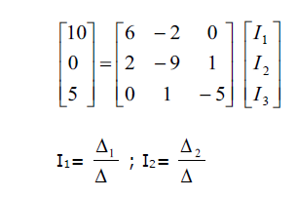

#### 6

∆= 2

#### 0

− 2 0

− 9 1

1  5

 6(45  1)  2(10)  244

10

∆1= 0

#### 5

− 2 0

− 9 1

1  5

 10(45  1)  2(5)  430

6 10

∆2= 2 0

#### 0 5

0

#### 1  6(5)  10(10)  70

− 5

I = 1 = 430  1.762 *A*

1

I2=



 2 =

#### 

244

##### 70  0.286 *A*

244

| I1- I2|= 1.476

P2Ω=(| I1- I2| )2 *2=(1.476)2*2= 4.357 watts

Therefore Power dissipated across 2Ω resistor is 4.357 watts.

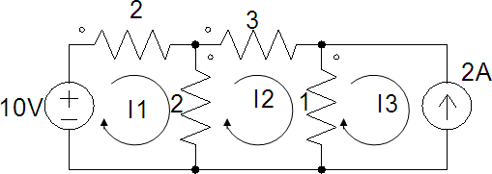*Example 2*: Find the energy dissipated across 3Ω resistor for the duration of 42 seconds in the given network as shown in fig.

*Solution:*

For mesh (1)

-10+2I1+2(I1-I2) =0

2I1- I2=5 (1)

For mesh (2)

3 I2+1(I2-I3)+2(I2-I1)=0

2I1-6I2+I3=0 (2)

For mesh (3) I3=-I=-2A

Substituting I3 in (2) 2I1-6I2-2=0

2I1-6I2=2 (3)

Solving (1) and (3) 2I1- I2=5

2I1-6I2=2

----------------------- 5 I2 =3

I2 =3/5=0.6 A

Power dissipated across 3Ω resistor is P= I2R = (0.6)23=1.08 watt

Energy dissipated across 3Ω resistor for 42 seconds is W=Pt = I2Rt= 1.08 X 42= 45.36 Joules

Therefore energy dissipated across 3Ω resistor for 42 seconds is 45.36 Joules.

* + 1. Super mesh method

The super mesh method can be introduced for any given electrical network if any two meshes are having common current source without parallel resistance (Ideal current source). Then voltage across ideal current source cannot be defined, for this condition to determine the mesh currents use super mesh method.

*Steps in Solving the networks using super Mesh analysis:*

Consider the below circuit as example for Mesh analysis

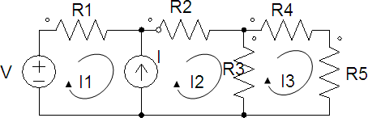

*Step 1:* Identify the two meshes where the common current source is present.

Assume the mesh currents as I1, I2,I3. Here mesh1 and mesh2 are having the common current source.

*Step 2:* Assume that there is no ideal current source, then apply KVL for mesh 1 and mesh 2 simultaneously writing one voltage equation.

-V+ I1 R1+ I2R2+( I2 - I3)R3=0

V= I1 R1+ I2 (R2+ R3) - I3R3 (1)

Applying KVL for mesh 3 I3R4+ I3R5 +(I3 - I2)R3=0

- I2R3 +( R4+R5+ R3)I3 =0 (2)

*Step 3:* Define common Ideal current source in terms of mesh currents. i.e, I=(I2 - I1 ) (3)

From equations (1), (2) and (3) get the values of I1, I2,I3.

*Example 4:* Find the voltage across 3Ω resistor in the circuit shown below.

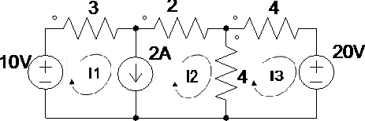

*Solution:*

Let the mesh currents for three meshes be I1, I2,& I3

Mesh 1 Mesh 2 are having common Ideal current source then to analyze the circuit apply super mesh method.

By super mesh method

-10+3I1+2I2+4(I2-I3)=0

10=3I1+6I2-4I3 (1)

For mesh (3) by KVL 4I3+20+4(I3- I2) =0

8I3-4I2=-20

I2-2I3=5 (2)

Defining the Ideal current source value I1-I2 = 2 (3)

By Crammer’s method

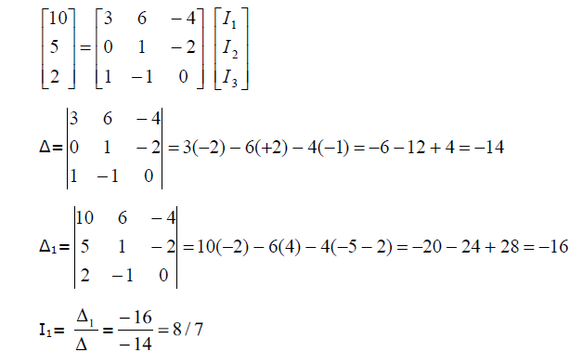

Voltage across the 3Ω resistor V3 =R3I1 =3*8/7=3.428V

* 1. Nodal Analysis:

A node is a point in a network, where two or more elements meet. Nodal analysis is a combination of KCL (Kirchhoff’s Current Law) and ohm’s law.

*Steps in solving the networks using Nodal analysis:*

Consider the below circuit as example for Mesh analysis

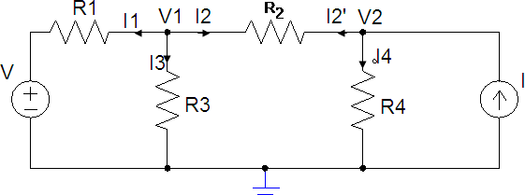

*Step 1:* Identify the number of principle nodes in the given circuit. (3 principle nodes in this case).

*Step 2:* Assume the node voltage and consider one node as a reference node which should be connected to the ground (potential as 0V)

*Step 3:* Apply KCL first and Ohm’s law next at every node, and obtain the current equations.

At node V1 (assume V1>V, V1>V2)

I1+I2+I3 =0

𝑉1−𝑉

𝑅1

+ 𝑉1−𝑉2

𝑅2

+𝑉1−0 =0

𝑅3



At node V2 (assume V2>V, V2>V1)

I2’+I4 =I

#### V2 − V1 R2

V2 − 0

+

R4

#### = 𝐼

**

*Step 4:* Determine V1 and V2 by using the normal method or Matrix method.

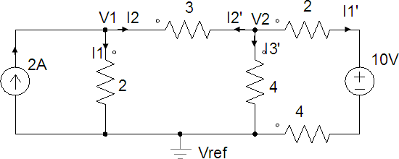*Example 5:* Find the voltage drop across 3 Ω resistance for a given network as shown in figure.

*Soln:* At node V1

I= I1+I2 2= I1+I2



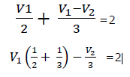

At node V1

5V1-2V2=12 (1)

I1’+I2’+I3’ =0

𝑉2−10−0

4+2

+ 𝑉2 −𝑉1

3

+ 𝑉2−0 =0

4

#### 1 1 1 10 𝑉1

𝑉2 (6 + 3 + 4) − 6 − 3 = 0

From (1) & (2)

From (1)

9𝑉2 − 4𝑉1 = 20……………………….. (2)

20V1-8V2=48

-20V1+45V2=100

37V2=148 V2 = 4 V

5V1-8=12

V1 = 4V

Voltage drop across 3 Ω resistor = |V1- V2| =|4-4|=0

Therefore 3 Ω resistor is short circuited and voltage drop across it is zero.

*Example 5:* Find the resistance value of the ‘R’ for the give circuit.

R

2

2A

6V

V 3

19/6 A

6 12V

*Solution:* By assuming the unknown principal voltage as V across the 6 Ω resistance Applying KCL at node ‘V’

𝑉−6 + 𝑉−0 + 𝑉−12 =0

2 6 3

1 1 1

𝑉 ( +

2 3

+ ) − 3 − 4 = 0

6

V(1)=7 ; V=7V

Let i be the current through (R)

At node 12V At node 6V

19/6= (12-6)/R + (12-7)/3 2 = (7-6)/2 + (12-6)/R

6/R = 19/6 – 10/6 6/R = 2- 1/2

R=4 R = 4

Therefore The resistance for the given circuit ‘R’ = 4 Ω

* + 1. Super node method

If two nodes in any electrical network are having common Ideal Voltage source (A voltage source without series resistance) then between those two nodes we cannot define the current, then use the super node to analyze the circuit.

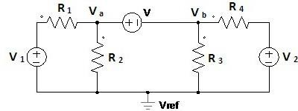Consider the below circuit as example for Super node analysis.

*Step 1:* Identify the two nodes which are having common Ideal voltage source.

*Step 2:* Assume that there is no voltage source in between them, apply KCL at two nodes write down in common current equation.

*Step 3:* Define common Ideal voltage source value in terms of unknown nde voltages.

*Step 4:* Solve the obtained equations to get the unknown values.

Nodes Va and Vb are having common Ideal voltage source

By KCL at Va and Vb (By considering no voltage source between Va and Vb )

𝑉𝑎−𝑉1−0

+ 𝑉𝑎−0 + 𝑉𝑏−𝑉2 + 𝑉𝑏−0

𝑅1

𝑅2

𝑅4

𝑅3

## 𝑉 [1

=0

+ 1 ] + 𝑉

[1 + 1 ] = 𝑉1 + 𝑉2 ………… (1)

𝑎 𝑅1

𝑅2

𝑏 𝑅4

𝑅3

𝑅1

𝑅4

Define the Ideal voltage source

Va - Vb =V (2)

From (1) and (2)solving Va and Vb can be found

*Example 6:* Find the value of I for the given circuit shown in the below fig.

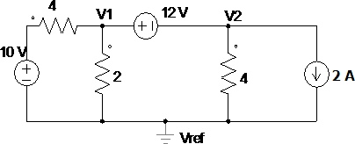

*Solution:*

Let V1 and V2 be the nodes

V1 and V2 have common Ideal Voltage source (12V) By KCL at V1 and V2 writing down in one equation.

𝑉1−10 + 1−0 + 𝑉2−0 + 2 =0

4 2 4

3 V1 + V2 =2 (1)

By defining the ideal voltage source V1 - V2 =12 (2)

From (1) and (2)

4 V1=14 V1 = 3.5V V1 = 12+ V2

V2 = 3.5-12 = -8.5 V

I = V2 /4= -8.5/4 =-2.125 A

2.3. Star - Delta (Y- ∆ ) transformation

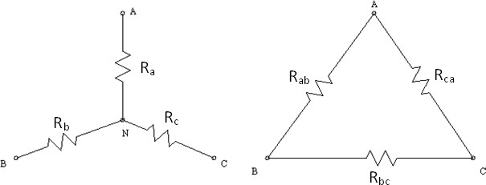The methods of series, parallel and series – parallel combination of elements do not always lead to simplification of networks. Such networks are handled by Star Delta transformation.

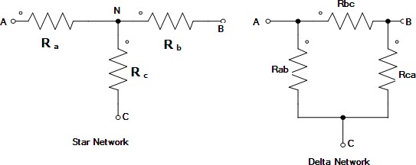

Figure a shows three resistances Ra, Rb, Rc connected in star to three nodes A,B,C and a common point N & figure b shows three resistances connected in delta between the same three nodes A,B,C. If these two networks are to be equivalent then the resistance between any pair of nodes of the delta connected network of a) must be the same as that between the same pair of nodes of the star – connected network of fig b).

* + 1. Star resistances in terms of delta

Equating resistance between node pair AB

Ra + Rb

= Rab

// (Rbc

+ Rca

) = 𝑅𝑎𝑏 𝑅𝑏𝑐+𝑅𝑎𝑏 𝑅𝑐𝑎

𝑅𝑎𝑏+𝑅𝑏𝑐+𝑅𝑐𝑎

_ (1)

Similarly for node pair BC

For Node pair CA

Rb + Rc

= Rbc

// (Rca

+ Rab

) = 𝑅𝑏𝑐 𝑅𝑐𝑎+𝑅𝑏𝑐 𝑅𝑎𝑏

𝑅𝑎𝑏+𝑅𝑏𝑐+𝑅𝑐𝑎

_ (2)

Rc + Ra

= Rca

// (Rab

+ Rbc

) = 𝑅𝑐𝑎 𝑅𝑎𝑏+𝑅𝑐𝑎 𝑅𝑏𝑐

𝑅𝑎𝑏+𝑅𝑏𝑐+𝑅𝑐𝑎

_ (3)

Subtracting 2 from 3 gives

Ra – Rb

= 𝑅𝑐𝑎 𝑅𝑎𝑏+𝑅𝑏𝑐 𝑅𝑎𝑏

𝑅𝑎𝑏+𝑅𝑏𝑐+𝑅𝑐𝑎

_ (4)

Adding 1 and 4 gives

R = 𝑅𝑎𝑏𝑅𝑐𝑎

a

𝑅𝑎𝑏 +𝑅𝑏𝑐+𝑅𝑐𝑎

_ (5)

Similarly

R = 𝑅𝑏𝑐 𝑅𝑎𝑏

b

𝑅𝑎𝑏+𝑅𝑏𝑐+𝑅𝑐𝑎

_ (6)

R = 𝑅𝑐𝑎𝑅𝑏𝑐

c

𝑅𝑎𝑏+𝑅𝑏𝑐+𝑅𝑐𝑎

_ (7)

Thus the equivalent star resistance connected to a node is equal to the product of the two delta resistances connected to the same node decided by the sum of delta resistances.

* + 1. Delta resistances in terms of star resistances:

Dividing (5) by (6) gives

𝑅𝑎 = 𝑅𝑐𝑎

∴ 𝑅

= 𝑅𝑎𝑅𝑏𝑐

𝑅𝑏

𝑅𝑏𝑐

𝑐𝑎

𝑅𝑏

Dividing (5) by (6) give



Substituting for Rab & Rca in equation (5) simplifying gives

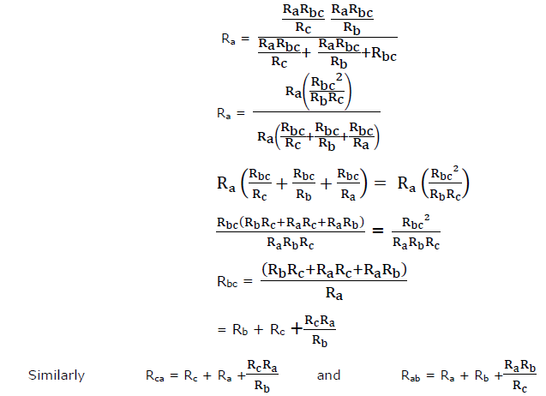

Thus the equivalent Delta resistance between two nodes is the sum of two star resistances connected to those nodes plus the product of the same two star resistances divided by the third star resistance.

R = RARB

1

RA +RB +RC

R1R2

RA =R1 + R­2+

R3

R = RARC

2

RA +RB +RC

R1R3

RB = R1 + R3 +

R2

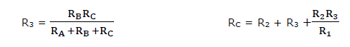

If all are similar resistors and equal to R

R2 R

R1 = =

3R 3

#### RA = 3R

PROBLEMS:

**1.) Convert the following circuit in to star circuit**

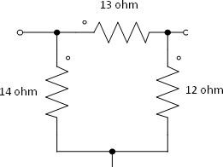Sol.) R1= RARB

RA +RB +RC

R2= RARC

RA +RB +RC

R3= RBRC

RA +RB +RC

=13*12/(13+12+14)=4 ohm

=13*14/(13+12+14)=4.66 ohm

=12*14/(13+12+14)=4.31 ohm

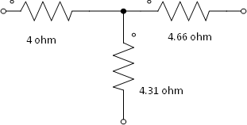

2.) Convert the following circuit in to delta circuit

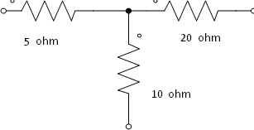

Sol.) RA

= R1

+ R2

R1R2

+ =5+20+5*20/10=35 ohm

R3

R1R3

RB = R1 + R3 +

RC = R2 + R3 +

R2 R2R3

R1

###### =20+10+20*10/5=70 ohm

=5+10+5*10/20=17.5 ohm

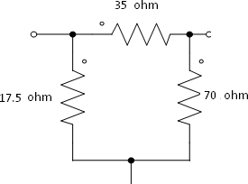

**DC Response of an R-L Circuit:**

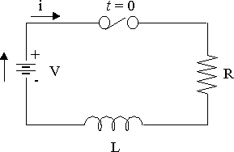

Consider a circuit consisting of a resistance and inductance as shown in fig. the inductor in the circuit is initially uncharged and is in series with the resistor. When switch S is closed, we can find the complete solution for current. Application of Kirchhoff’s law to the circuit results in following differential equations.

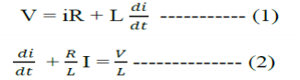

In the above equation, the current i is the solution to be found and V is the applied constant voltage. The voltage V is applied to the circuit only when the switch S is closed. The above equation is linear differential equation of the first order comparing with the non homogenous differential equation



Where c is an arbitrary constant, in similar way we can write the current equation as

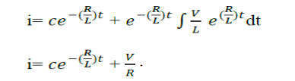

To determine the value of ‘c’, in above equation we use initial conditions. In the circuit shown in fig the switch S is closed at t=0. At t=0–, i.e. just before closing the switch S, the current in the inductor is zero. Since the inductor does not allow sudden changes in currents, at t=0+ just after the switch is closed, the current remains zero.

Substituting above conditions we get, 0 = c +(V/R) Therefore, c = -V/R

Hence from equation

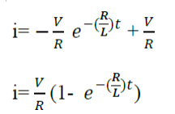

Above equation consists of two parts, the steady state part (V/R) and other is transient part.

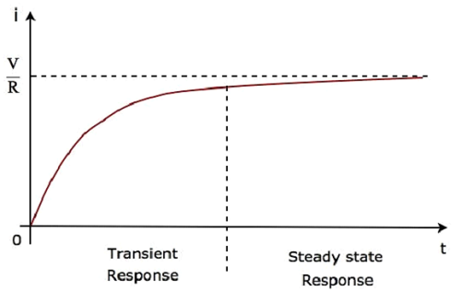

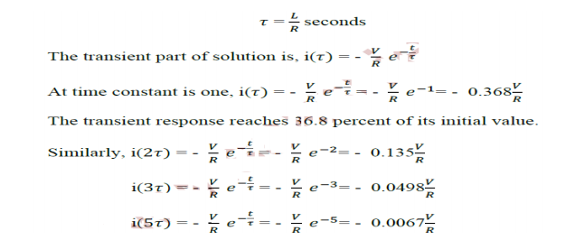

After 5, the transient part reaches more than 99 percent of its final value. In fig we can find out the voltages and powers across each element by using the current.

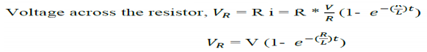

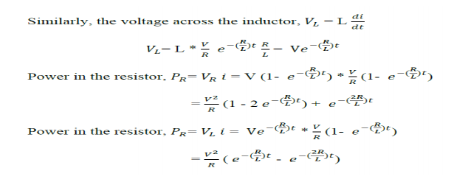

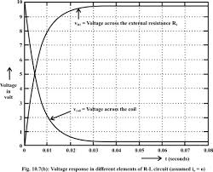

**DC Response of an R-C Circuit:**

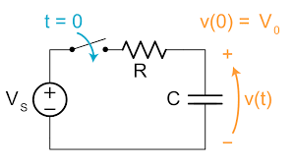

Consider a circuit consisting of resistance and capacitance as shown in fig. the capacitor in the circuit is initially uncharged, and is in series with resistor. When the switch S is closed at t=0, we can determine the complete solution for current. Application of Kirchhoff’s laws we can determine the differential equations.

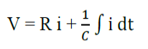

By differentiating the above equation we get,

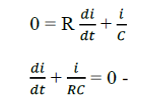

Equation is linear differential equation with only the complementary function. The particular solution for the above equation is zero. The solution for this type of differential equation is



Here, to find the value of c, we use the initial conditions. In the circuit shown in fig switch S is closed at t=0. Since the capacitor never allows sudden changes in voltage, it will act as short at t=0+. So, the current in the circuit at t=0+ is V/R. Substituting the i value in equation we get,



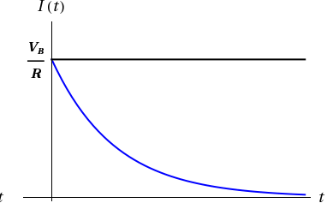

When switch S is closed, the response decays with time as shown in fig. In the solution, the quantity RC is the time constant, and is denoted by r, where r= RC seconds. After 5, the transient part reaches more than 99 percent of its final value. In fig we can find out the voltage across each element by using the current equation. Voltage across the resistor



Similarly, voltage across the capacitor

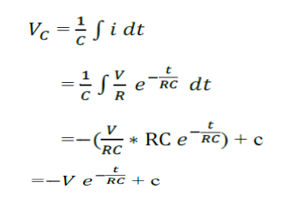

At t=0, voltage across the capacitor is zero.

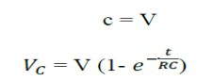

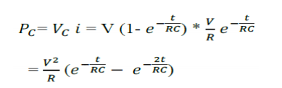

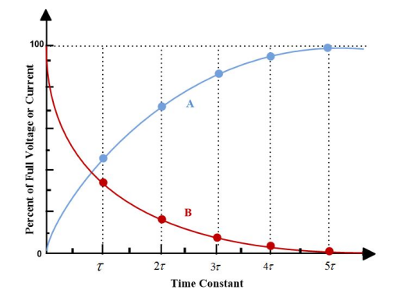A---VC B-----VR